Node js application with docker and kubernetes

Minikube start:

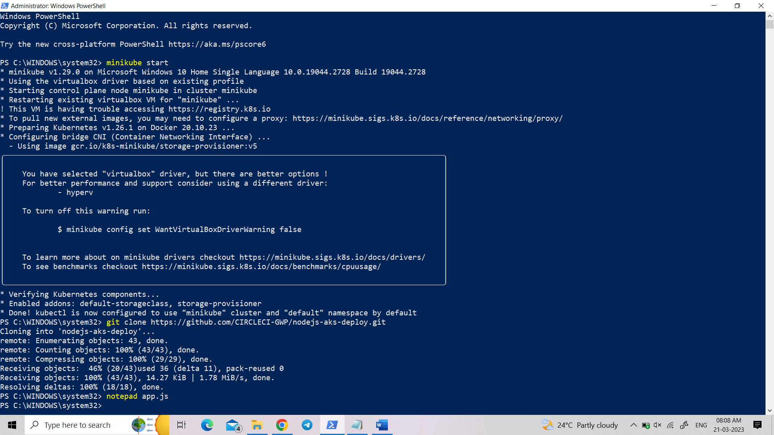

Clone git repository: git clone <https://github.com/CIRCLECI-GWP/nodejs-aks-deploy.git>

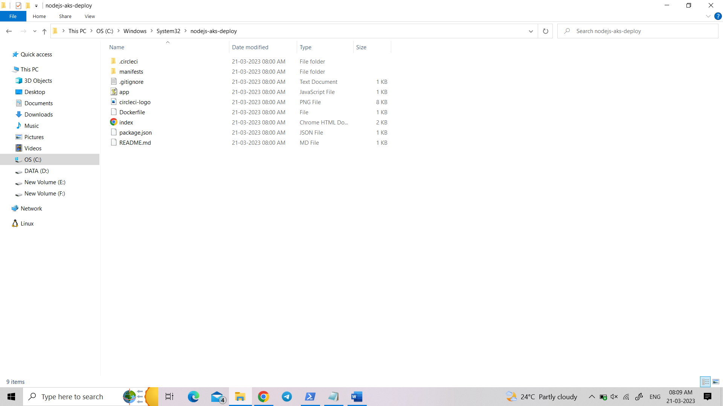

Create app.js file:

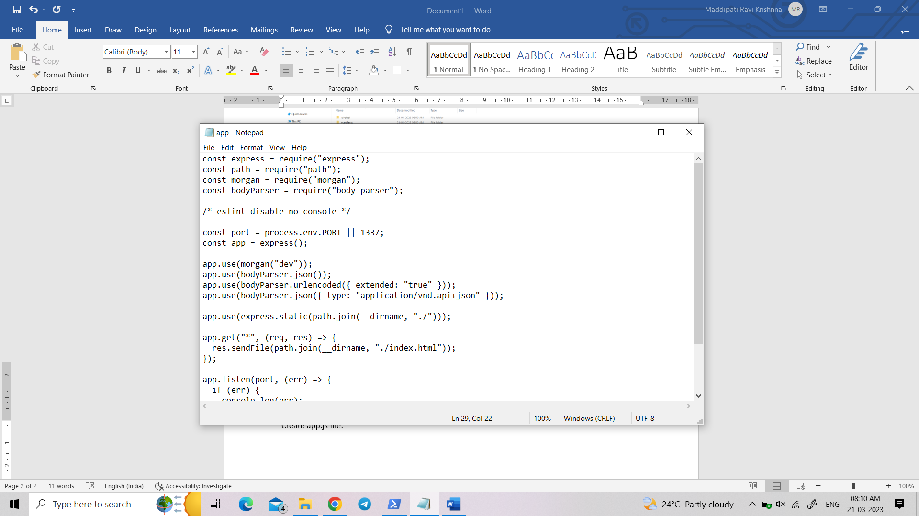

In path go to nodejs-aks-deploy and do npm install:

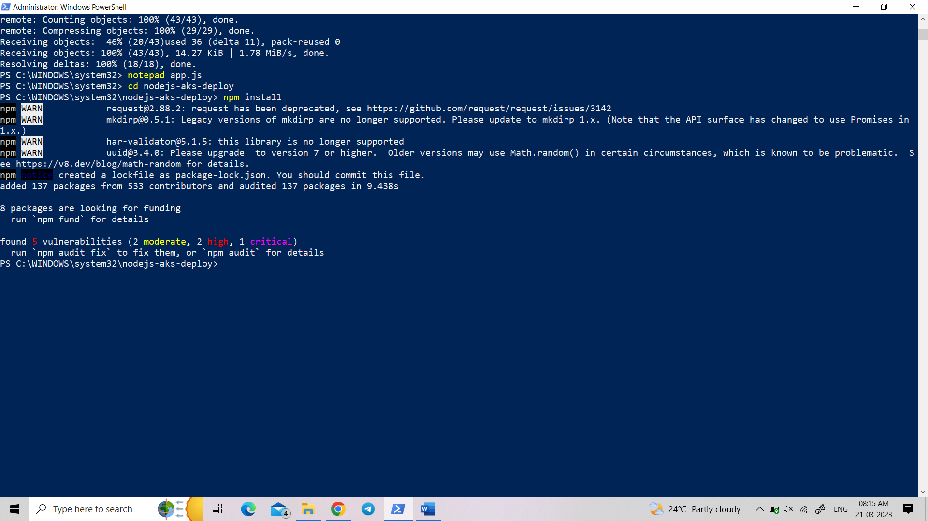

Node app.js:

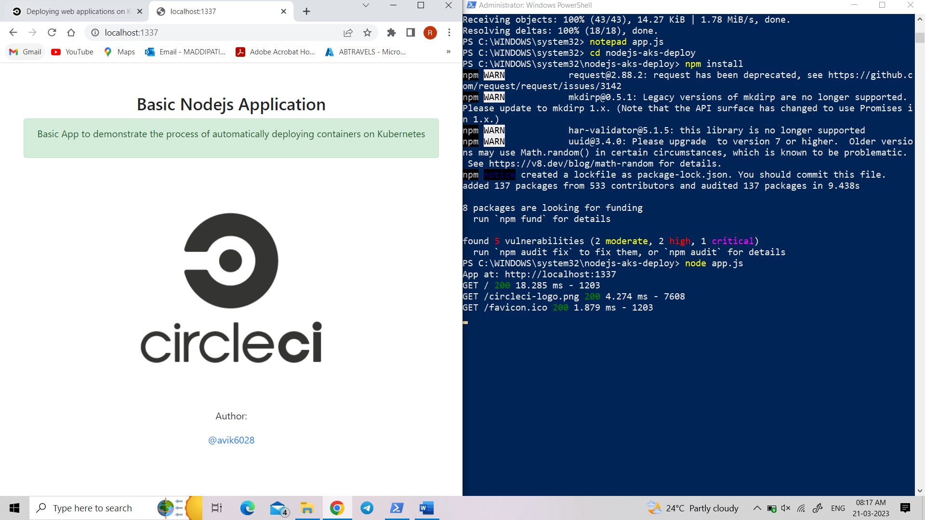

url: <http://localhost:1337>

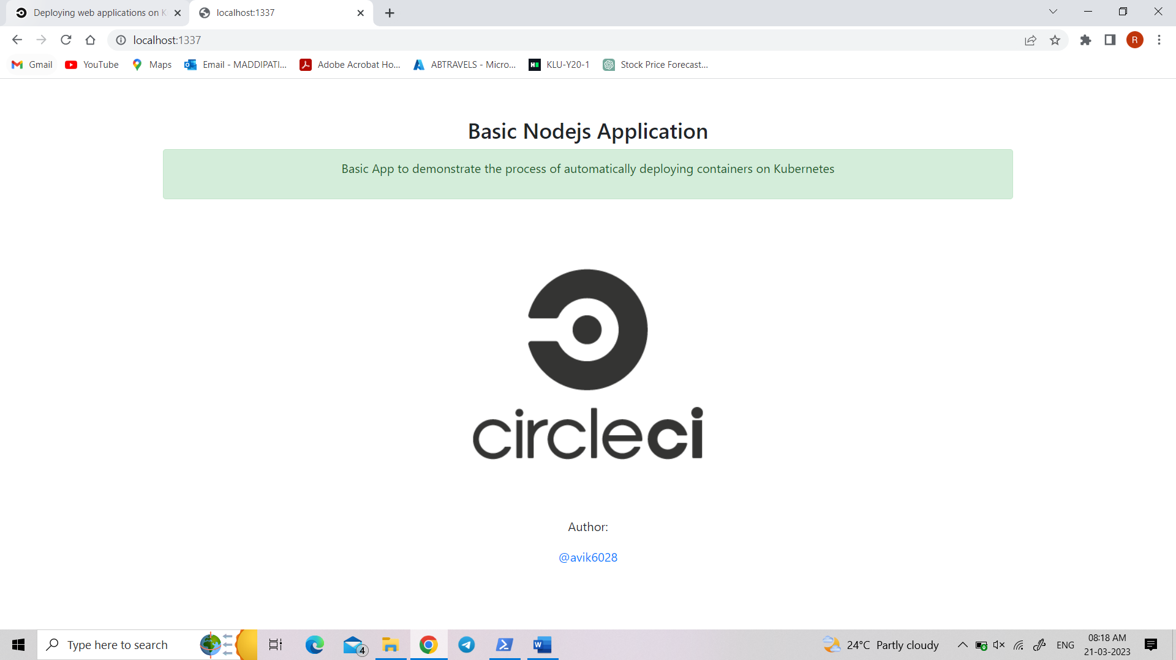

Open docker and type docker build -t nodejs-aks-app:latest . in PowerShell

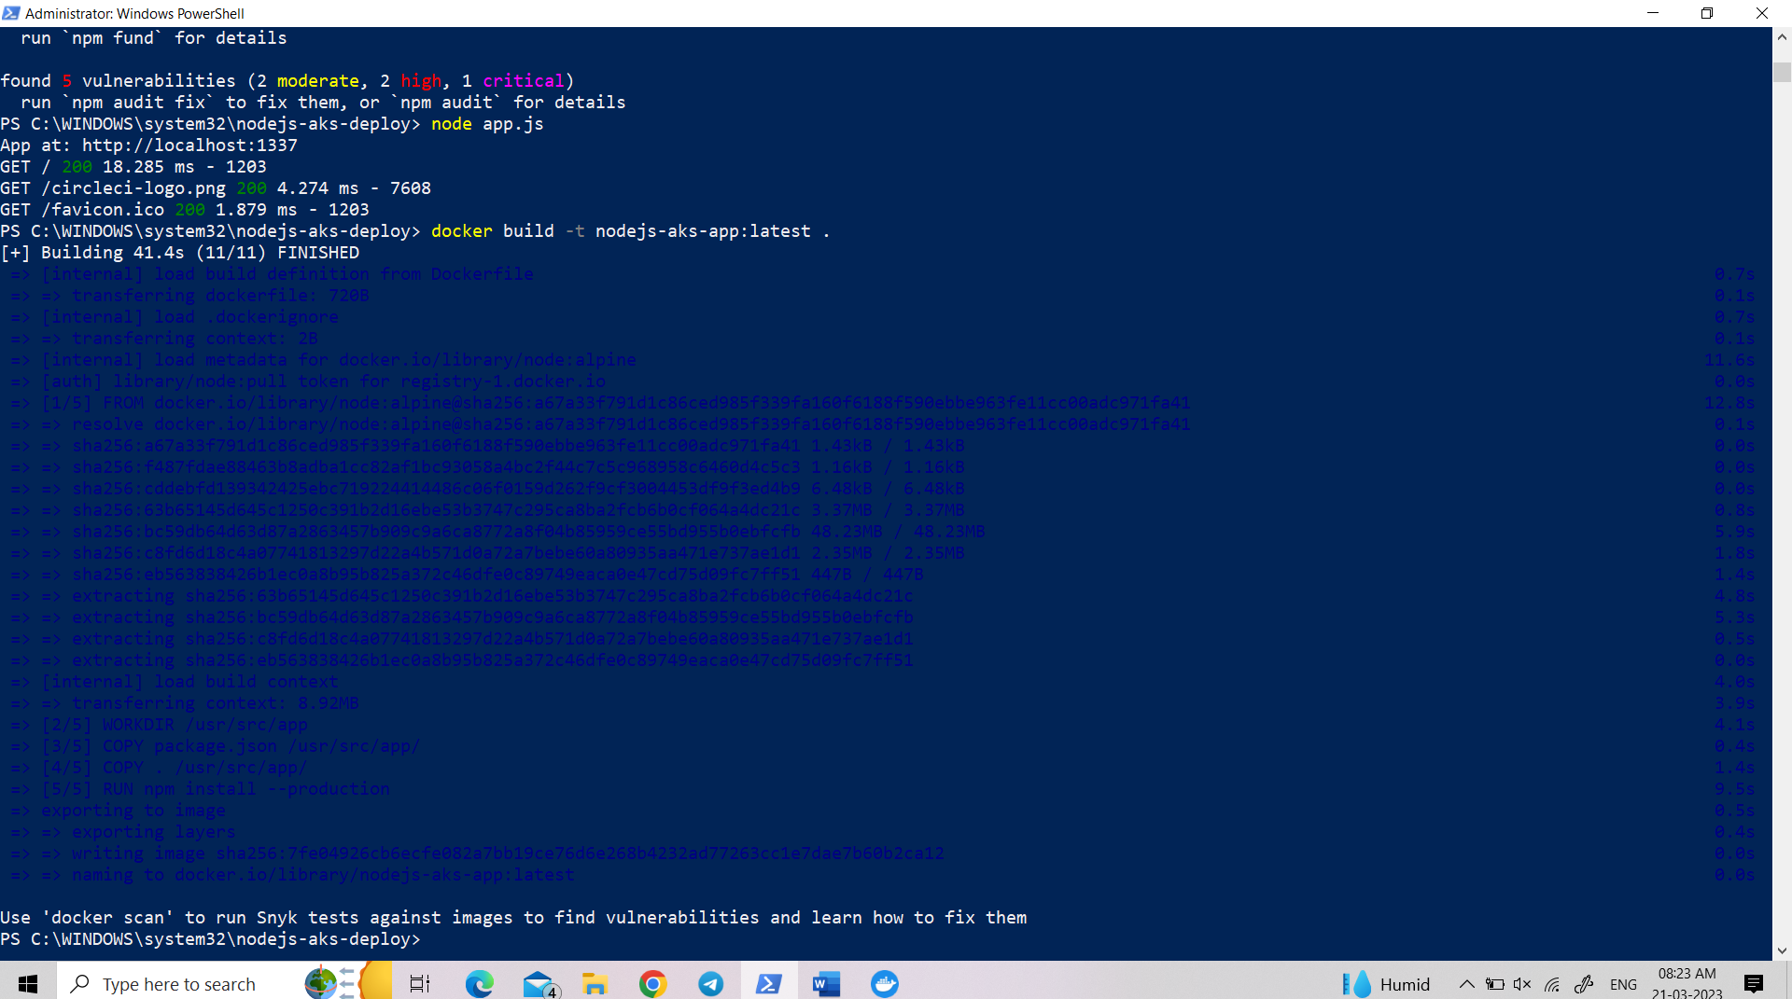

Image is created in docker desktop:

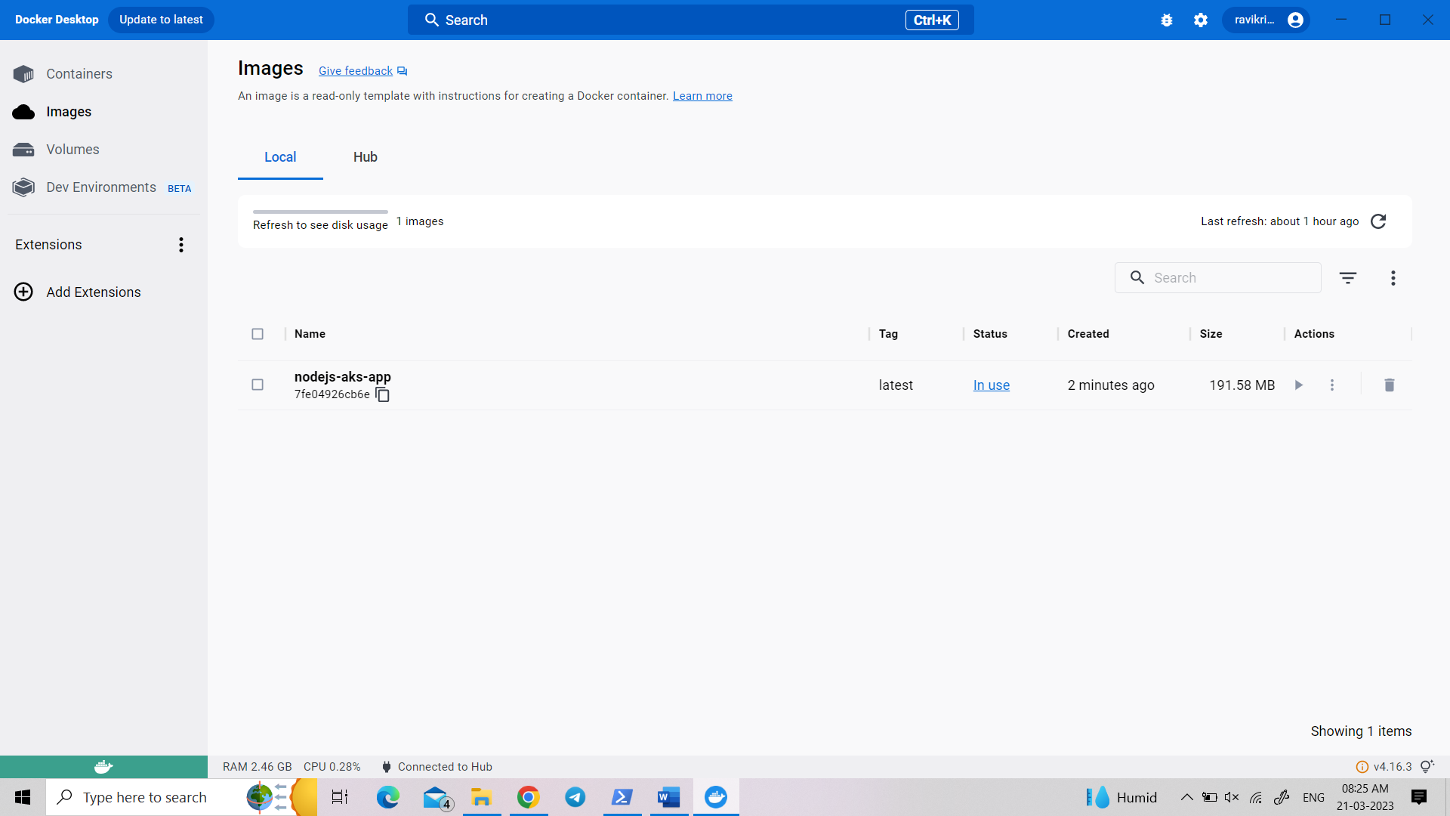

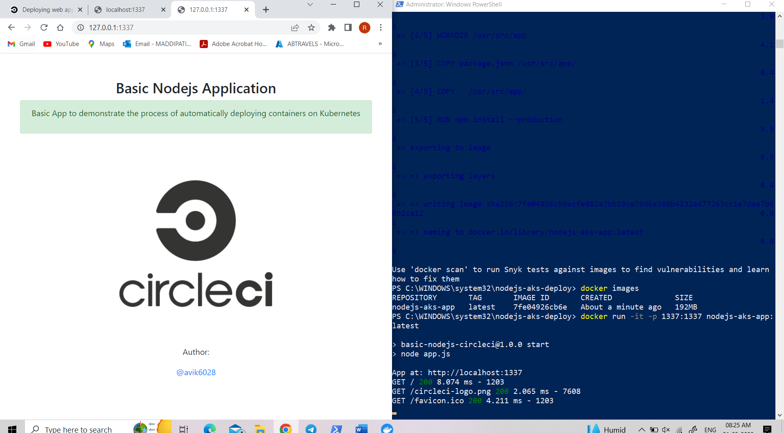

Runs on port: http://127.0.0.1:1337

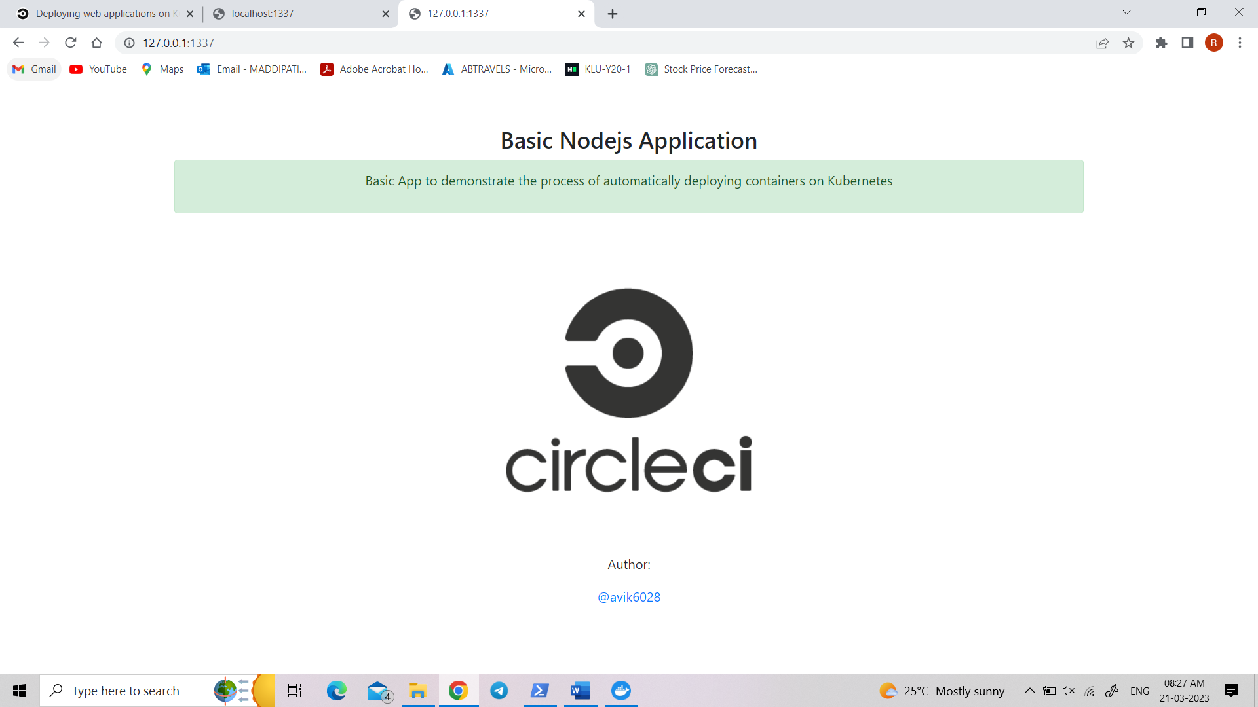

Using Kubernetes

Go to manifests directory in nodejs-aks-deploy folder

Open namespace.yaml file

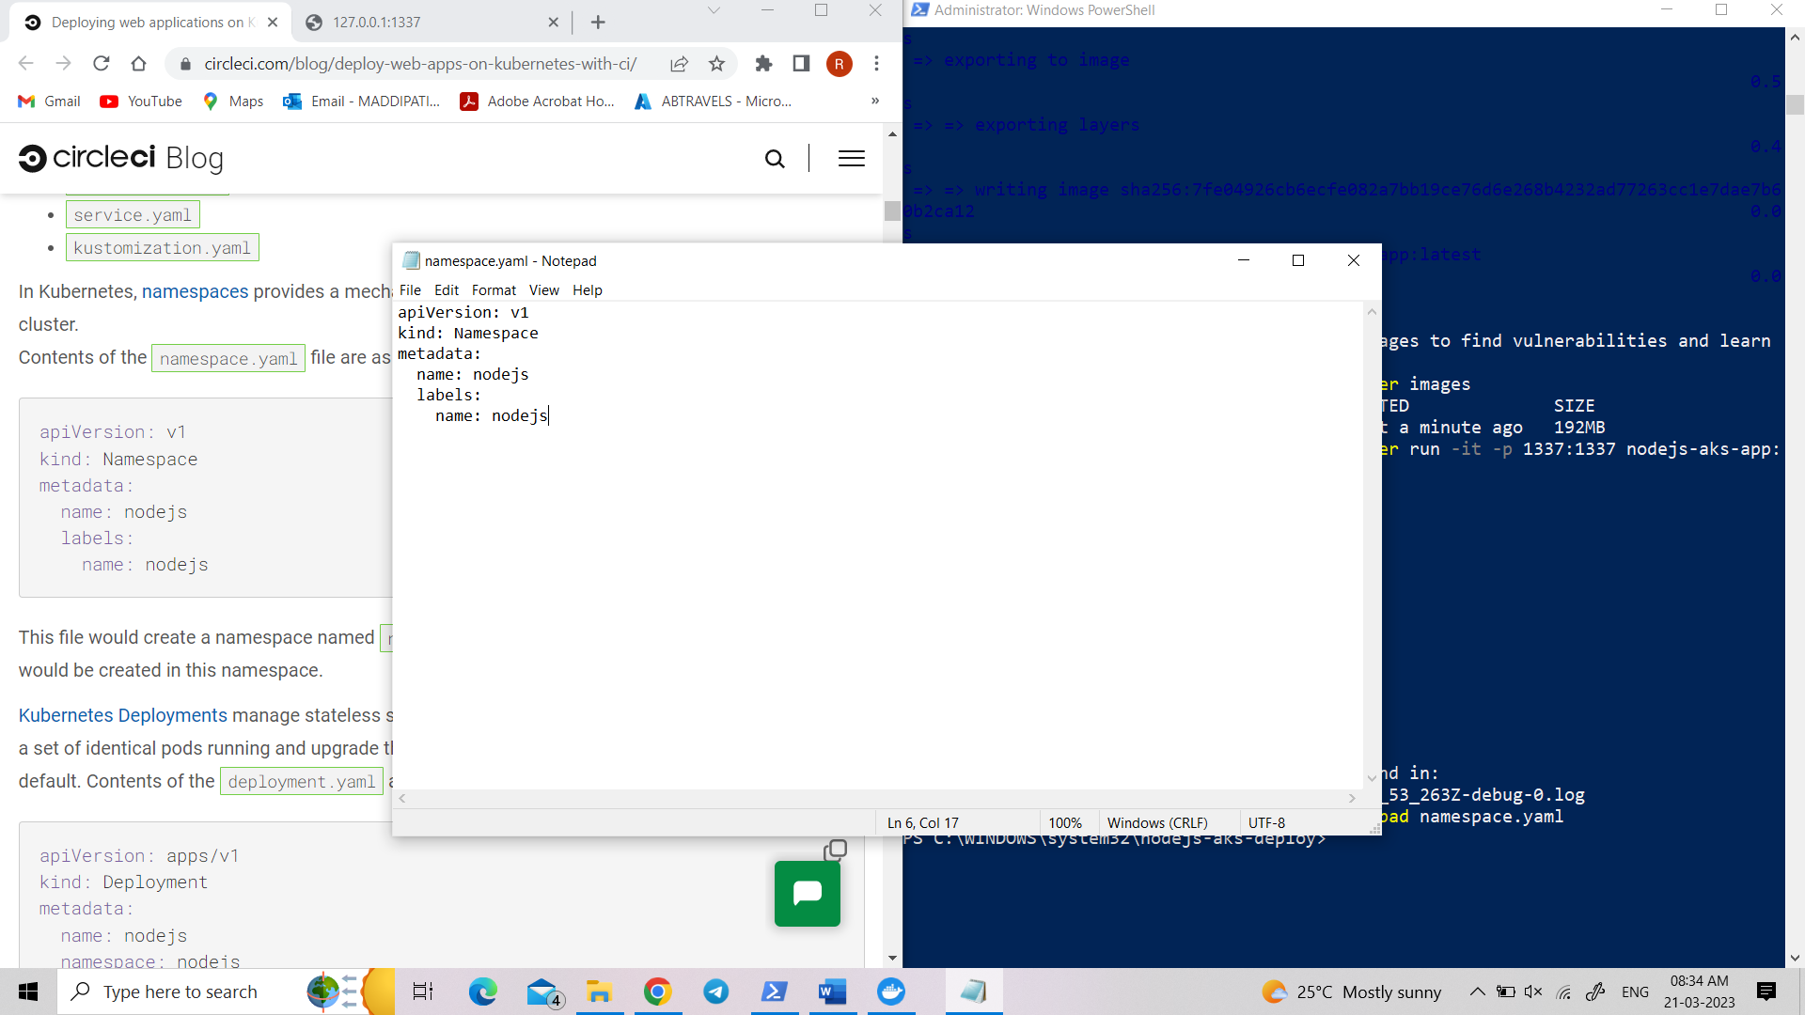

Open service.yaml and paste:

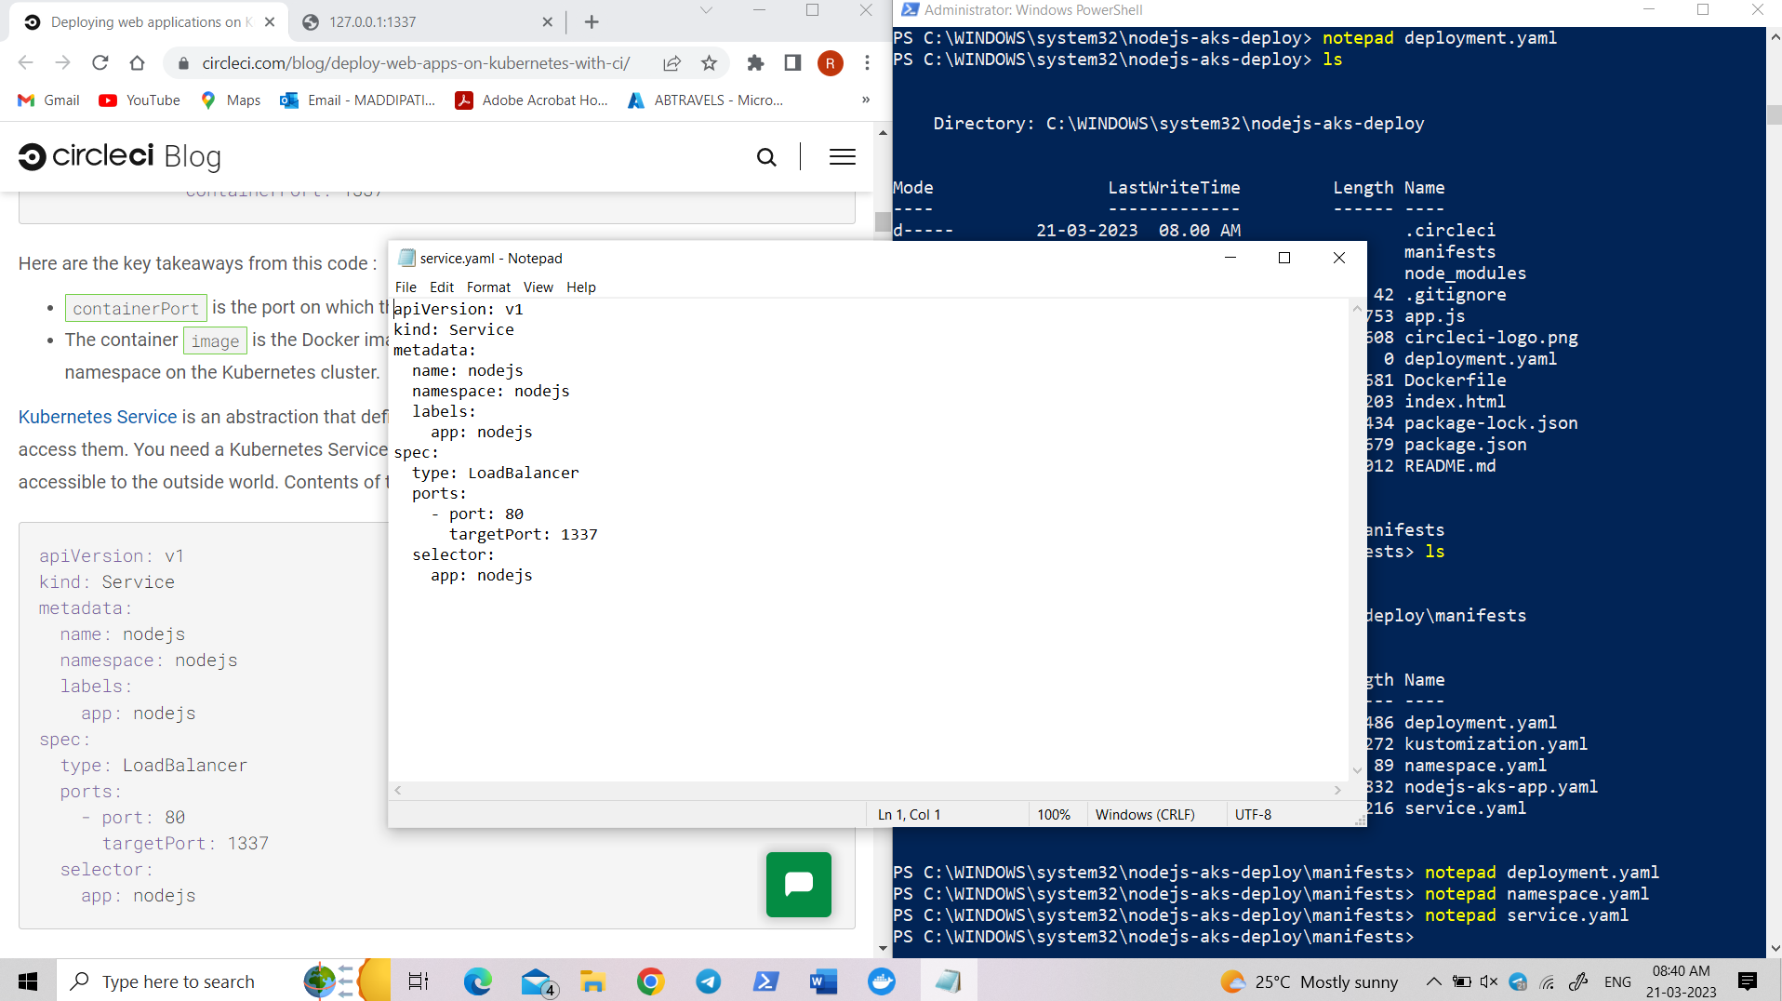

In kustomaization.yaml:

